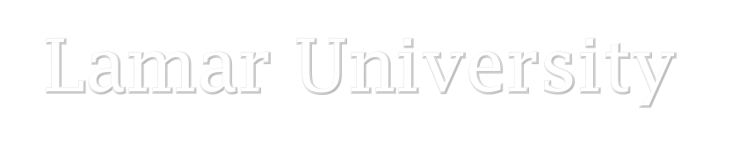

College of Education and Human Development Department of Educational Leadership
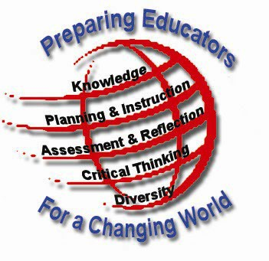
The CONCEPTUAL FRAMEWORK of the Lamar University undergraduate and graduate educator preparation programs illuminates the vision of the faculty. The programs prepare educators for a changing world by requiring as outcomes general education, pedagogical content knowledge, content proficiency, pedagogical strategies, communication skills, values, and analytical abilities. Critical thinking is required for responding to the diverse needs of PK-12 students in myriad and changing settings. Lamar University educator preparation candidates also develop dispositions and habits of mind needed for “self-learning” and lifelong learning”, that will equip them to encounter problems and change with confidence.

Syllabus
MOOC Course Name: Social Media: Communication Tools for Educators
Fall 2014
5 Weeks

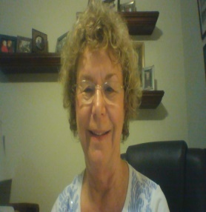

Instructor

Dr. Kay Abernathy, Ed.D. Office Location: ED 233
Telephone: 409.880.8689
(office) 409:880-7608 (cell) 832-712-6155
Fax: (409) 880-8685
- mail: lkabernathy@lamar.edu
Office Hours: Virtually By Appointment
Virtual Office Hours: Wednesdays 5-8 pm
Web Conferences: Tuesday nights at 7pm Central Time

Course Description
This course is designed to provide a place for participants to learn, teach, share, and discuss important topics related to using social media tools for communication in the educational
environment.

Course Rationale
This course gives students the opportunity to interact with and experience the use of social media tools. The course goal is to share and experience hands-on digital tools for communicating in the educational environment.

Course Goal and Objectives
The course goal is to improve digital age communication skills and give educators experience to explore social media tools and use them to connect in a positive way for specific audiences of community, parents, teachers, university faculty, administrators, students, and/or policy makers.

Learner-Centered Outcomes

By the end of the course the learner who wants to earn a certificate of completion will:

- Explore a minimum of six social media tools and complete at least three digital communication documents addressing community, parents, teachers, university faculty, administrators, and/or students.
- Complete pre-assessment and post-assessment surveys.
- Complete reflections.
- Complete optional peer editing assignments.
- Create annotations of selected course readings and videos.
- Participate in optional web conferences.
- Participate in online discussions with colleagues.
- Consume, create, and collaborate using social media tools for improving educator communication and student learning.

Suggested References

In addition to readings, web references, and discussions within each module, learners are encouraged to consider adding the following resources to their professional libraries:

- Magana, S. & Marzano, R.J. (2014). Enhancing the Art & Science of Teaching with Technology. Bloomington, IN: Marzano Research Laboratory.

- Mlligan, Littlejohn, & Margaryan (2013). Patterns of engagement in connectivist MOOCs. http://tinyurl.com/MOOC-by-Milligan.

- Rheingold, H. (2012). Net smart: How to survive online. Cambridge, MA: The MIT Press.

Citations for Referenced MOOC Resources

Ferdig, R. E., Pytash, K. E., Merchant, W., & Nigh, J. (2014). Findings and reflections from the K-12 teaching in the 21st century MOOC. Lansing, MI: Michigan Virtual Learning Research Institute. Retrieved from http://media.mivu.org/institute/pdf/Mooc_Findings.pdf

Jackson, Maggie (2008). Attention Class. Retrieved April 25, 2014 from: http://www.boston.com/bostonglobe/ideas/articles/2008/06/29/attention_class/?page=full

Kleiman, G., Wolf, M., & Frye, D., (2013). The Digital Learning Transition MOOC for Educators: Exploring a Scalable Approach to Professional Development. Retrieved April 25, 2014 from: http://all4ed.org/reports-factsheets/the-digital-learning-transition-mooc-for- educators-exploring-a-scalable-approach-to-professional-development/

Milligan, C., Littlejohn, A., & Margaryan, A. (2013). Patterns of engagement in connectivist MOOCs. MERLOT Journal of Online Learning and Teaching, 9 (2), 149-159.

Rheingold, H. (2012) The New Power of Collaboration. Retrieved April 25, 2013 from: http://www.ted.com/talks/howard_rheingold_on_collaboration.html

Rheingold, H. Syllabus: Social Media Literacies/College/University Level, Seed Version. Retrieved from: https://docs.google.com/document/d/1whawicjQdSDh1ohWF4- CDnSrrpkjfFtnpc6632vGBvg/edit.

Course Expectations
Learning in this massive online open course will take place through lectures (both written and audio), assigned readings, and applicable assignments by learners for improving communication in an educational environment using social media tools.

Options for Participants as Learners
- Learners only enroll to consume as much as they can about tools and readings related to using social media for communicating in an educational environment. All learners are urged to participate whenever they can. Guidelines ask learners to consume, create, and collaborate as much as is beneficial for them.

- Learners decide to demonstrate their competency within individual parts of the course and earn digital badges for components of the course they complete without completing the entire MOOC. If learners complete the consume, create, and collaborate activities for each of the assignment content areas, they earn a badge for each of the content component assignments. Learners can earn up to ten badges (pre-assessment survey, post-assessment survey, three content areas activities, two optional peer review activities, and an optional bibliographic assignment).

- The MOOC is created to engage learners in many aspects of using social media for communication in educational environments in order to earn a certificate of completion, continuing education credits, or professional development credit for their work. A participant who earns all ten badges automatically receives an end of course certificate. Earning the five badges should take approximately six to eight hours each week for a total of 40 hours.

- Infographic: cMOOC and xMOOC

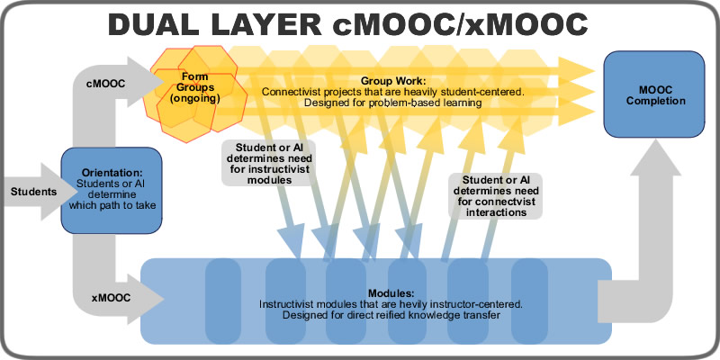

Special Accommodations
It is the policy of Lamar University to accommodate students with disabilities, pursuant to federal and state law, and the University’s commitment to equal educational opportunities. Any student with a disability who needs accommodation should contact Lamar University’s Office of Services for Students with Disabilities.
The Office of Services for Students with Disabilities (SFSWD) offers a variety of services designed to assure qualified students with disabilities (SWD) access to the university’s activities, programs, and services.

To receive academic adjustments and/or accommodations, contact the SFSWD Director at 409-880-8347 or email SFSWD@lamar.edu to make an appointment to submit documentation of disability and to discuss disability-based academic adjustments/accommodations. Services are provided free of charge for qualified students who have provided proper documentation and completed the intake process.

Academic Honesty
In addition to the knowledge and skills necessary for all learners, dispositions (such as honesty and trust) are important qualities of a successful educator. Learner candidates are expected to conduct themselves in a professional manner. Academic dishonesty will not be condoned. Plagiarism is copying another’s work without proper citation. Guidelines for direct quotes are found in the most current APA Style Manual. The professor will assign a reasonable penalty for academic dishonesty. If you do not agree to the findings and/or the penalty, you must file an appeal with the department chairperson within five days, as provided by the Student Handbook.

Academic Continuity Plan
In the event of an announced campus closure in excess of four days due to a hurricane or other disaster, students are expected to login to Lamar University’s website’s homepage www.lamar.edu for instructions about continuing courses remotely.

Syllabus Subject to Change
While information and assurances are provided in this course syllabus, it should be
understood that content may change in keeping with new research and literature and that events beyond the control of the instructor could occur. Students will be informed of any
substantive occurrences that will produce syllabus changes.

Evaluation and Assessment

Week 1.1 -- Assignment – Pre-Assessment Survey – 1 Badge 50
Week 1.2 -- Assignment – Discussion Board Responses 50
Week 1.3 – Assignment – Register and submit links to Twitter account,
Facebook account, and Word Press account. 50
Week 1.4 – Readings and video assignments 100
Week 1.5 – Assignment – Blog reflection in your class blog site 100
(Recommended WordPress but your personal choice).
Week 2.1 -- Assignment – Pre-planning and Discussion Board Responses 50
Week 2.2 – Assignment – Readings, Videos, and Planning the Personal
Learning Network 50
Week 2.3 – Assignment – Create, Determine, Analyze, Value of Experts
for Personal/Professional Learning Community. (Communicate
and follow on Twitter the experts for 7 days, record and analyze
their tweets on social media tool. Conribute through our reflective
blog about the process of creating your PLN an the importance
of your PLN to your learning.—1 Badge 100
Week 2.4 – Your Contributions: Reflective Blog 100 Points 100
Week 2.5 – Optional Assignment -- Blog Reflection and Optional Peer
Reflection Assignment to include review and feedback for your
PLN and two colleagues’ PLNs 100
Week 3.1 -- Assignment – Pre-planning and Discussion Board Responses 50
Week 3.2 – Readings and videos and planning assignments 100
Week 3.3 – Assignment – Create and determine social media tool for
Newsletter or newspaper. 1 Badge 100
Week 3.4 – Blog Reflection and Assignment 100
Week 3.5 -- Optional Self- and Peer-Reflection Assignment 100
Week 4.1 -- Pre-planning and Discussion Board 50
Week 4.2 -- Readings, discussions assignments 100
Week 4.3 -- Create communique for policy makers 1 Badge 100
Week 4.4 -- Your Contributions: Reflective Blog 100
Week 4.5 – Optional Peer and Self Assessment 100
Week 5.1 – Discussion Board 50
Week 5.2 -- Reading, Videos, and Notes 50
Week 5.3 – Closing Reflection 100
Week 5.4 -- Post-Assessment Survey – 1 Badge 50

Self- and Peer- Assessment Scale for Certificate of Completion

Description of Assignments

Pre-assessment Survey: This survey gives us the demographic information of those who register for the MOOC and their rationale for registering. Data should give information about students’ learning styles and their reasons for taking the course to help us improve the design of the MOOC.

Post-assessment Survey: This survey gives us the demographic information of those who choose to take the survey and gives us some understanding of the value and benefits of the MOOC for the participants currently and in the future.

Discussion Board: Actively participating in the discussions regarding MOOCs, social media tools, and digital communications is encouraged in this course. Response to two or more questions per week including dialogue with a minimum of two other learners is expected.

Consume, Create, and Collaborate Activities: The major work in the MOOC course is done within the activities. The first stage of the activity is to consume the recommended readings and videos. Complete suggested readings and videos and add resources to the class Twitter hashtag, “#LU Social Media MOOC”. New resources should also be shared to the “LU Social Media for Communication MOOC” in Facebook. You must register at Twitter and Facebook to share ideas, writings, and resources using these social media tools.

The second stage of the activity is to explore thoroughly a minimum of two social media tools appropriate for the activity and to create a communication for a selected audience.

The third stage of the activity is to collaborate with others in the class in the Discussion Board after you post your communication activity, self-edit your communication product,peer-edit a minimum of two communication products for colleagues in the class, and then write a reflective piece on the learning.

Resources for Reflective Writing:
https://student.unsw.edu.au/reflective-writing
http://www.lc.unsw.edu.au/onlib/pdf/reflective.pdf
http://www.port.ac.uk/media/contacts-and-departments/student-support-services/ask/downloads/Reflective-writing---a-basic-introduction.pdf

Optional Peer Editing Assignments: See Resources for the course for peer editing suggestions which were: retrieved on March 26, 2014, from http://writing.colostate.edu/guides/teaching/fys/prhandout.cfm
http://www.colby.edu/writers.center/peerediting.html

Annotated Bibliography:
https://owl.english.purdue.edu/owl/resource/614/01/
https://owl.english.purdue.edu/owl/resource/614/03/
https://writingcenter.unc.edu/handouts/annotated-bibliographies/

 | Social Media Activities for Communication
Dates | Weekly Videos and Readings | Assignments
Week 1 – Overview of Social Media Tools for Communication MOOC. | - Read assigned pages related to the MOOC format.  - Watch social media videos in Blackboard. | - Complete pre-assessment survey.  - Open accounts in Twitter and Evernote if you are not registered there.  - Discussion and reflection of open courses and social media tools.
Week 2 – Communicating with Experts | - Read assigned pages related to personal learning networks and peer review process.  - Watch videos as assigned in Blackboard. | - Consume assigned readings and videos.  - Determine and follow five educational experts on Twitter.  - Post tweets in Evernote each expert in an individual notebook.  - Discussion of process and analysis of 7 days of tweets to determine which experts share most beneficial learning.  - Your Contribution: Reflection Blog  - Collaborate with others to peer review their processes and choices of experts.

 | Social Media Activities for Communication
Dates | Weekly Videos and Readings | Assignments
Week 3 – Communicating with Parents, Community, Colleagues, or Student Group | - Read assigned pages related to community newsletters and peer review process.  - Watch videos as assigned in Blackboard. | - Consume assigned readings and video.  - Determine a minimum of two social media newsletter or newspaper tools to fully explore.  - Using the one tool most beneficial for you, create a newsletter or newspaper for the general community or a selected community group.  - Your Contribution: Reflection Blog  - Collaborate with your colleagues in a peer review process after posting a reflective paper related to your learning.

 | Social Media Activities for Communication
Dates | Weekly Videos and Readings | Assignments
Week 4 – Connecting to Policy Makers | - Read assigned pages related to blogs and wikis for communication.  - Watch social media videos in Blackboard. | - Consume assigned readings and video.  - Create communique for policy makers.  - Your Contribution: Reflective Blog  - Discussion and reflection of open courses and social  media tools.

 | Social Media Activities for Communication
Dates | Weekly Videos and Readings | Assignments
Week 5 – Communicating Through MOCCs and Social Media – Post Assessment. | - Read assigned pages related to the MOOC format.  - Watch social media videos in Blackboard. | - Consume readings and videos.  - Your Contribution: Reflective Blog Write a closing reflection related to the value of social media for communication.  - Collaborate and share your writing with colleagues in the Twitter and Facebook groups.  - Complete post-assessment survey.  .

